Alternatives and Discussion

Our final class diagram for Phase 2 took form by separating our design function by function and adding new TimeLokum, and Level class to the first class diagram.

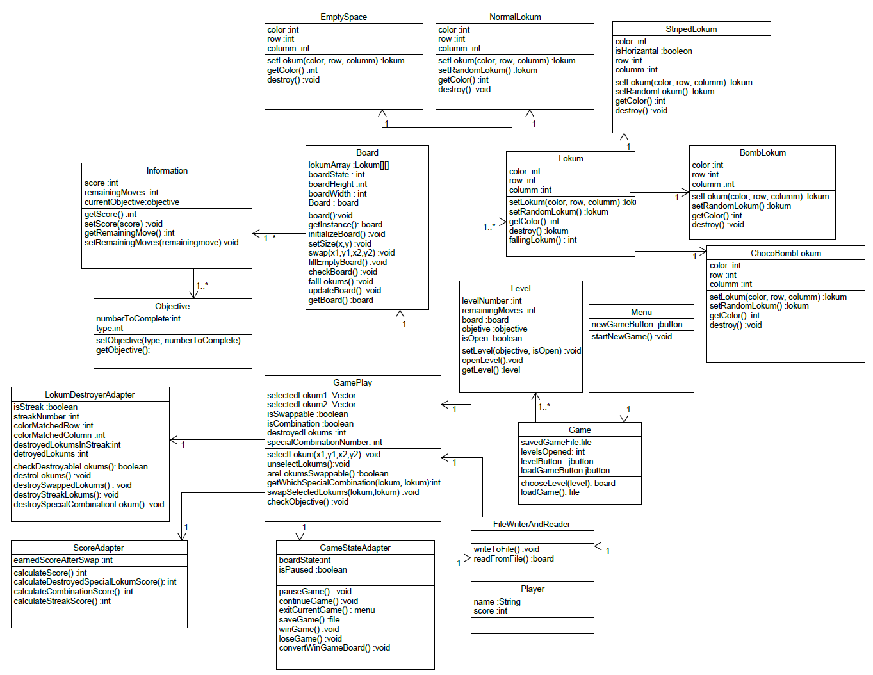

Figure 1: Class Diagram in Phase 1

At the first step, we decided to separate our design function by function. We have separated user interface and model. We have also improved user interface and made it more systematic as shown below picture.

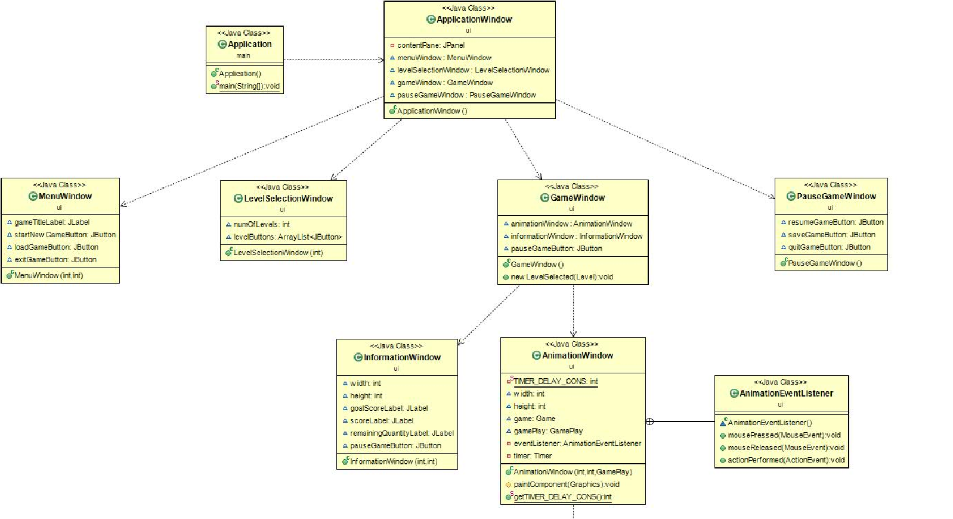

Figure 2: UI Part of Our Design

At the second step, we have separated model as objects and actions. We succeeded to separate it by using adapter design pattern and adding adapter for each action. Then, we added an adapter manager which is created by using singleton design pattern. AdapterManager controls every adapter in our design. Functionality of our adapters can be understood by their name. Our adapter are show below.

* DrawingAdapter
* LokumSwapperAdapter
* LokumCombinationAdapter
* LokumDestroyerAdapter
* LokumFallerAdapter
* ScoreCalculatorAdapter
* SimpleGraphicsDrawingAdapter
* RegularLokumSwapperAdapter
* SpecialLokumSwapperAdapter
* FallingLokumSwapperAdapter.
* SaveAndLoadAdapter

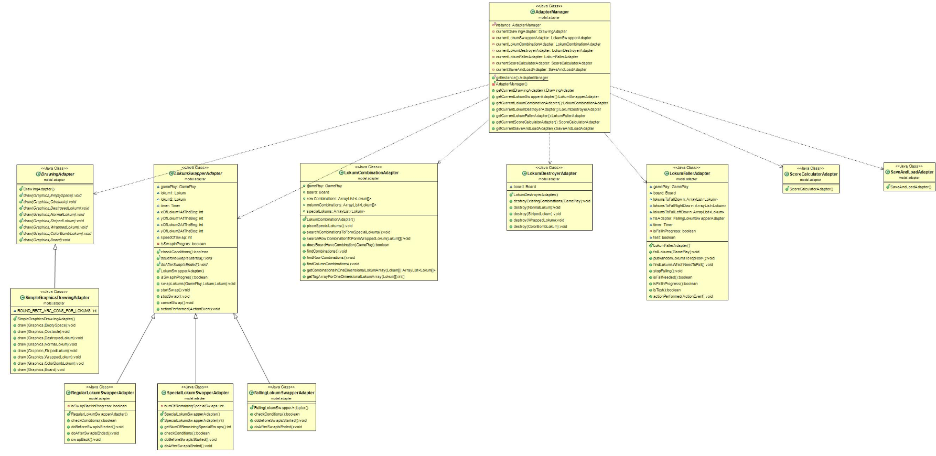

Figure 3: Adapter part of Our Design

At the third and last process, we have added new requirements which are SpecialLokumSwapperAdapter class, new Level class including TimeBasedLevel and MoveBasedLevel classes, and TimeLokum class. With these changes, we aimed to simplify our design and provided to ease adding new extensions. In this way, we achieved our final class diagram which can be seen below.

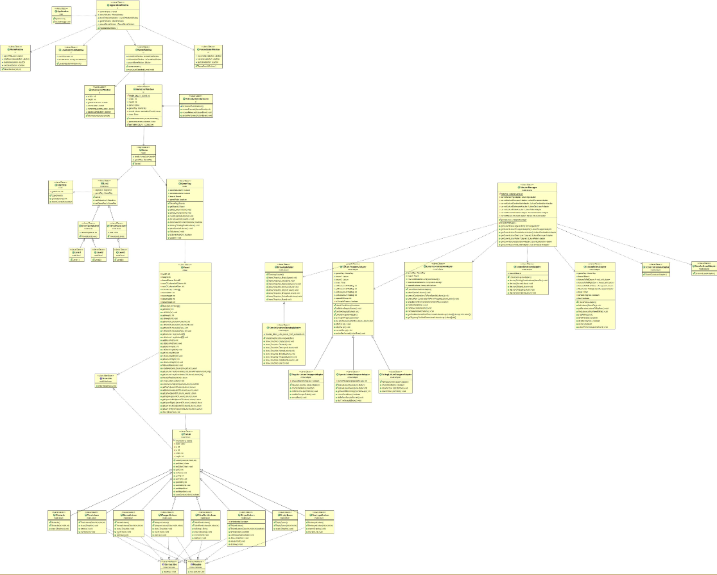

Figure 4: Our Final Class Diagram